CSC 120 Lab 04

**Code Refactoring exercise (**10 points)

Convert the following Python code into a function create_list(). The function create_list needs to return my_list. (Watch the lectures for how to create a list or how to write a function)

import random

my_list = []

MAX_LEN = 50

for i in range(MAX_LEN):

my_list.append(random.randint(1,99))

**Find minimum number in a list** (15 points)

Write a Python function to get the minimum element from the list created above. For example, if you have a list [11,4,6,2,29], your code should return you 2 as that is the minimum number.

(Code from both above are in this 🡫 Used my PyCharm, but I tried it in Google Colab, too)

Without using min(my_list):

def min_element(my_list):

my_list.sort()

return my_list[0]

**Leaderboard using a List (**25 points)

** Note: Read the article below on how to write pseudocode.I have provided an example of Psedocode for the maximum number finding algorithm in the Google Colab notebook. **Pseudocode writing guidelines** <https://student.cs.uwaterloo.ca/~cs231/resources/pseudocode.pdf>

Imagine you have a list ***top_scores*** that can store only 5 numbers. Implement an algorithm in Python for storing the top 5 scores in a list. Provide the code and the algorithm in pseudocode of your algorithm. Use the following steps

* Generate 50 random numbers in a loop.
* Try to add every number to the list.
* If list size is less than 5 all numbers generated get added.
* After the list size goes above 5 and a new number is generated, it gets added if it can feature in the top 5.
* For example, if the list currently has [10,12,5,9,11] and new number generated is 42, then 42 will get added and the lowest number 5 will get replaced. so the list will be [10,12,42,9,11]. If the next number generated is 3, nothing will happen as 3 is lesser than all the numbers in the list. **This is a hard question and you will really need to try to work this out using pencil and paper before trying to implement the algorithm in Python.** But if you get it, you have made a lot of progress!
* Email me with questions or quesries.

Algorithm:

*Import random from Python library*

*Num_list = empty list []*

*For each number in range(50)*

*Ran_num = generate random number*

*If Length(num_list) < 5*

*append ran_num to num_list*

*else if ran_num > min number in num_list*

*append ran_num to num_list, and remove min number from num_list*

*After loop has completed iterating, print num_list*

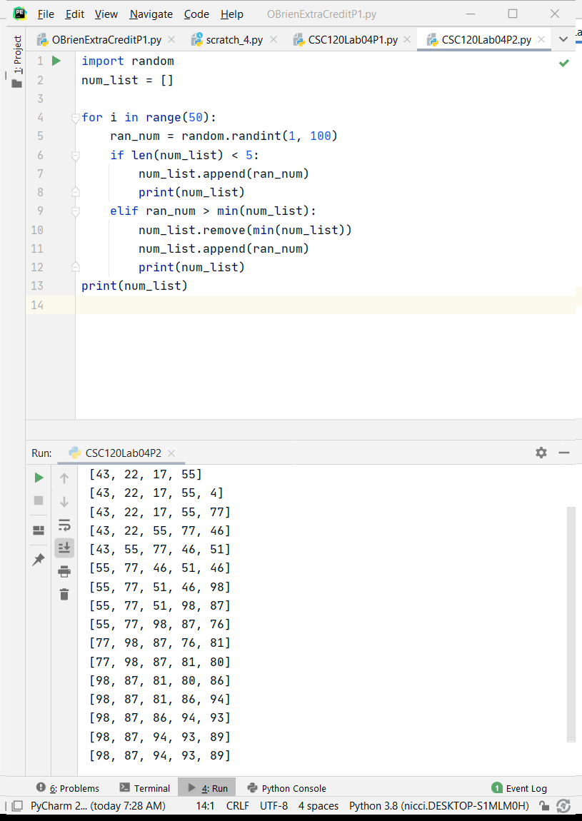

**Word Frequency Counter (**30 points)

Implement an algorithm to count the occurences of each word in the paragraph below. You can copy the text below as a string in your code. Your algorithm should be able to output all the words in the below paragraph and the count of how many times it occured in this text. For example, tech-hungry appears once in the below paragraph

**Use a dictionary as a data structure. Also use the string.split function. I will post a video on how string.split works so you need not spend time on learning how to make string,split works. Use the string provided below as the starting point. Copy all the italicized text below into your code.**

*e-wate_paragraph= "The Global E-waste Monitor 2020 report found that the world dumped a record 53.6 million tonnes of e-waste last year equivalent to the the weight of 350 cruise ships the size of the Queen Mary 2, or enough to form a line 125 kilometres long. That's an increase of 21 per cent in five years, the report said.Just 17.4 per cent of it was recycled, meaning that an estimated $57 billion worth of gold, silver, copper, platinum and other high-value, recoverable materials used as components were mostly dumped or burned rather than being collected for treatment and reuse.China, with 10.1 million tonnes, was the biggest contributor to e-waste, and the United States was second with 6.9 million tonnes. India, with 3.2 million tonnes, was third. Together these three countries accounted for nearly 38 per cent of the world's e-waste last year. The new report also predicts global e-waste discarded products with a battery or plug will reach 74 million tonnes by 2030 almost a doubling of e-waste in just 16 years.E-waste is a health and environmental hazard because it contains toxic additives or hazardous substances such as mercury. While the overall damage done to the environment from all the unrecycled waste may be incalculable, the message from the report was conclusive. The way in which we produce, consume and dispose of e-waste is unsustainable. Global warming is just one issue cited by the report as it noted 98 million tonnes of carbon dioxide equivalents were released into the atmosphere as a result of inadequate recycling of undocumented refrigerators and air-conditioners.What is happening in India and China is symptomatic of a wider problem in developing countries where demand for goods like washing machines, refrigerators and air conditioners is rising rapidly"*

**Your answer should produde an output similar to this.**

the: 19

of: 13

and: 8

e-waste: 7 ... and so on

(I think the count would be more accurate if special characters were stripped, but there are a lot in there, so it was a little too advanced for me to figure out just yet. One e-waste didn’t show up because it is ‘e-waste,’ as it appears later in the dictionary. There are also a few lines in this paragraph that do not have spaces between periods.)

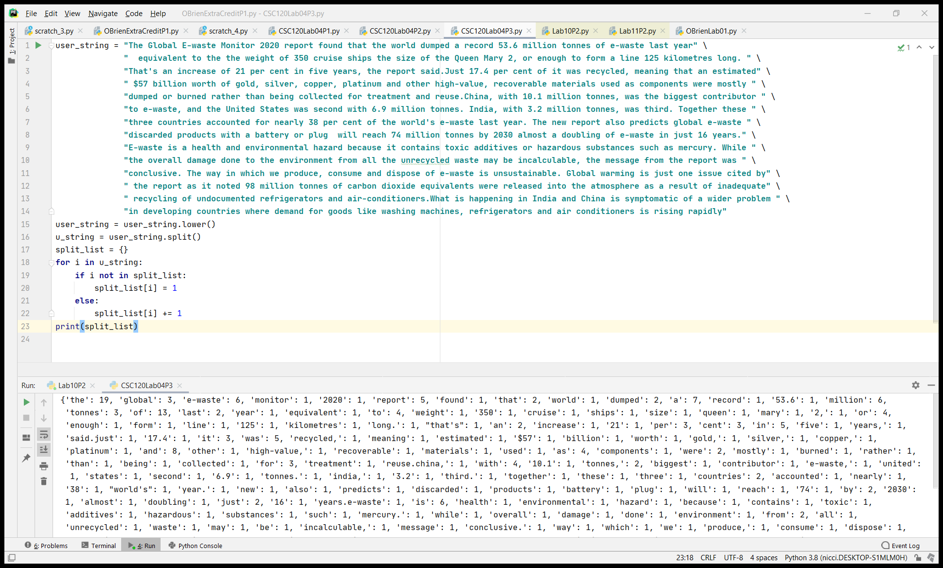

**Senior Fronend Engineer Position Description  (**20 points)

Here are the questions you should try to answer

* What is your understanding of a frontend engineer?
* What skills are necessary tp become one. Dont just list the names. Describe briefly. For example learning javascript or html.
* What courses do you think cvsn help you get there?
* What are some questions that you could not understand or answer about this position.

A frontend engineer works on the portion of a program or application that a user/client would see. They would work on creating the interface of the program that the user interacts with, while a backend developer would work on the process of how the user data is used and stored. Frontend development requires working with HTML (the basic structure of a webpage) CSS (the styling of a webpage), and JavaScript (which is a full-stack language that is often used in lieu of PHP (backend) to process input.)

A frontend developer should be able to work with images and content to create an optimal look for the program. Being able to code a well-structured HTML file and then apply a consistent CSS style to it is key to the aesthetics of a UI. Knowing, also, what input the user should provide and creating forms either through HTML or JavaScript and ensuring proper input validation is a big part of the job.

(I am actually working on an on-going project in CTI-110 that required us to create an algorithm for a concert ticket purchase program, then a website for the concert event and form for “buying” tickets, and then a PHP file to take the input and calculate the costs. We’ve also been doing a little work with MySQL to create a database. You can see my frontend (and backend PHP) work here: <https://apollo.waketech.edu/~nlobrien/obrien-group-l13-lab-project.html>

Courses in HTML, JavaScript, Python, and in design software would be very helpful for learning about frontend development.

There are quite a few terms I had to look up: VC’s (venture capitals,) React (a JavaScript library for creating UIs,) and SME/SMB (small enterprise/business.)

Sources:

<https://nimapinfotech.com/blog/frontend-developers-vs-backend-developers/>

<https://www.indeed.com/hire/job-description/front-end-developer?aceid=&gclid=Cj0KCQjwyZmEBhCpARIsALIzmnI_tvsp2zLCoFKSwYszFlxoZUn6GMOcTDu4QnOn7HD5kP6_6vwj74gaApFUEALw_wcB>

CTI-110 lessons and CSC-120 Computer Science textbook

**Bonus Questions Optional (advanced) for interested students**

* (+20) Create an algorithm to sort a list. You can use Bubble Sort , Insertion Sort or Selection Sort. Sort a list of 100000 numbers using this algorithm. Time your algorithm using the time module. Then sort this list using the inbuilt sorted() function in Python. How does the time of your algorithm compare to Python's running time.

(Changed to 10,000 because it was running way too long. The built-in sorted() function was much faster than the bubble sort algorithm I looked up online.)

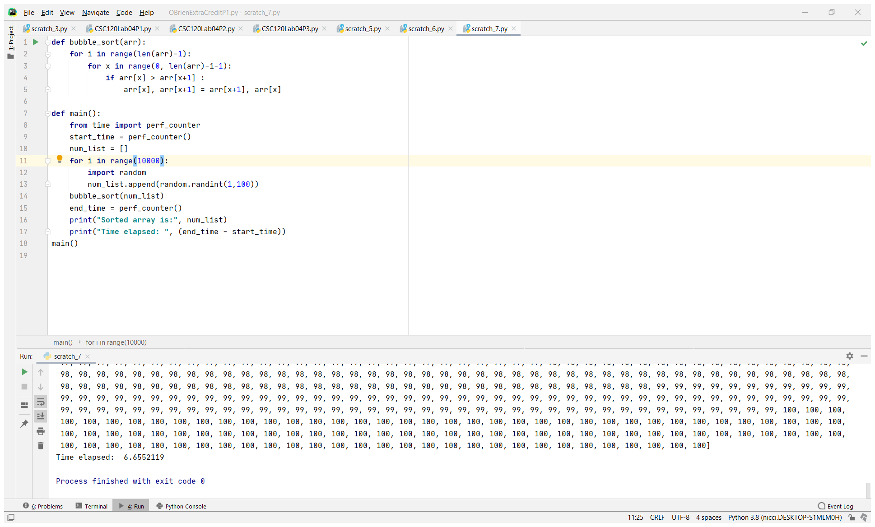

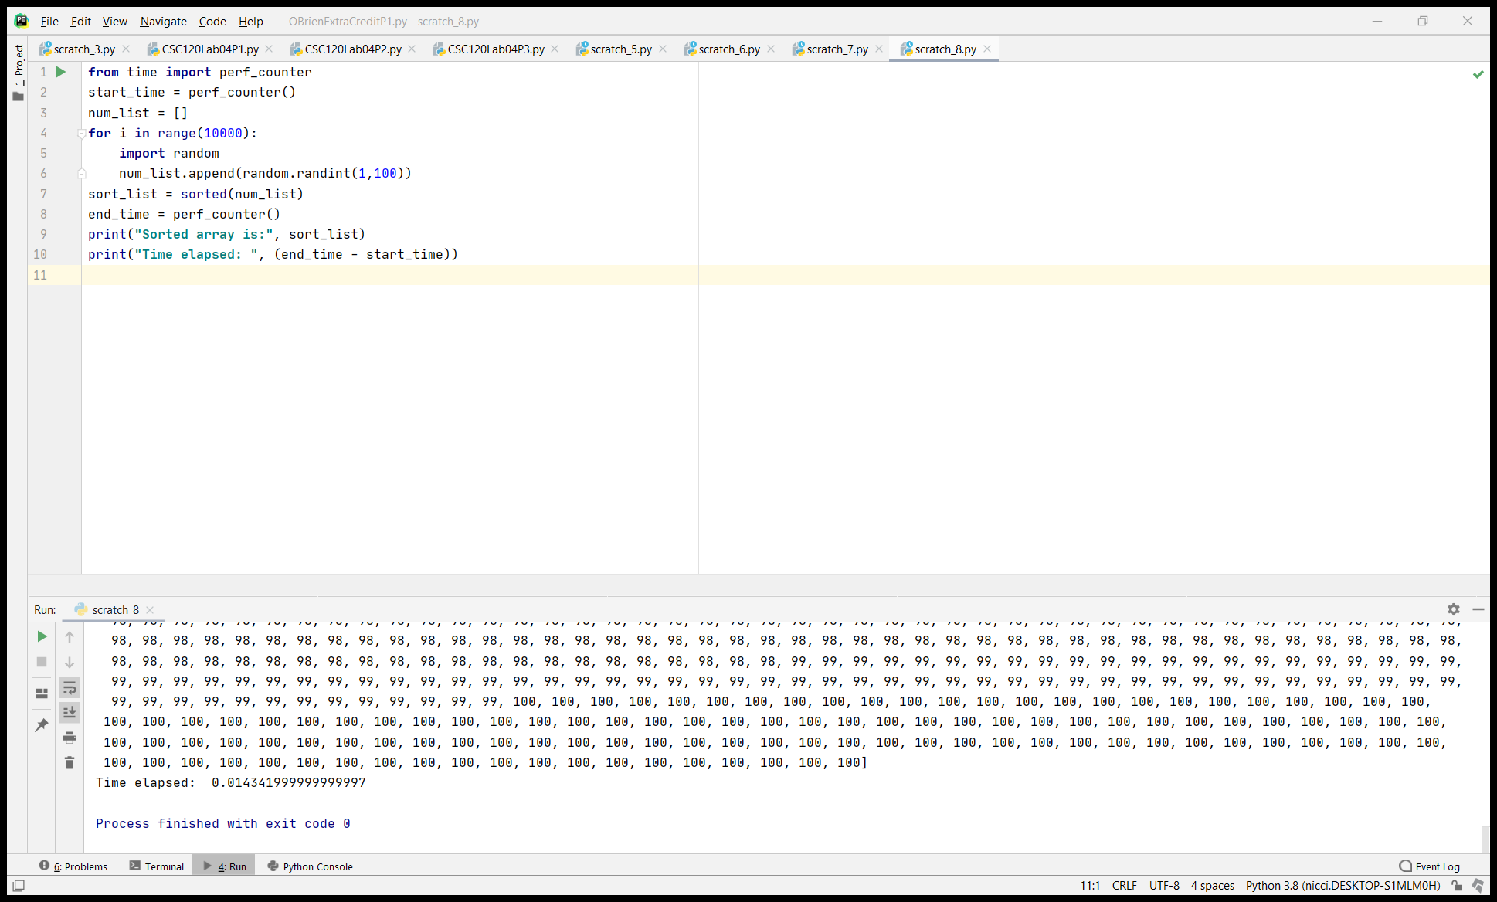

* (+10) How do you think about the efficiency of algorithms. How do you compare two algorithms in terms of their efficiency.

I would compare two algorithms’ efficiency by 1. The outcome of the algorithm (if it produces the correct, desired output,) 2. the amount of memory used in running the algorithm (how many variables created, how many functions, any unnecessary steps, etc.) and 3. the amount of time in which it takes to execute the algorithm from start to finish.

* (+10) How would you implement an undo button or a back button using Stacks?
* (+10 How would you implement a queue using the list in Python?
* (+10) What is the difference between linear search and binary search?

A linear search compares against each element in sequence, starting from the beginning, while a binary search compares against the middle of a sorted list and then goes from there, depending on if the middle is less than (proceeds to upper half) or greater then (proceeds to lower half) the element being searched.

By only searching the appropriate half for an element, process time is shortened. A binary search requires that the array be sorted, however.

Source:

<https://www.geeksforgeeks.org/python-program-for-binary-search/>

<https://medium.com/@ysmiracle/linear-search-vs-binary-search-and-why-we-should-approach-any-problem-using-binary-search-as-a-eca2f72d76b0>

* (+30) Do you think the top_scores algorithm can be optimized further? If so how?

I tried to re-imagine the top scores and see if, instead of comparing each number to the five in the list, it would be more efficient to add all to the list, then sort, and use negative indices to return the top 5, the timer shows about the same time result. (I know after the Teams chat today that this wouldn’t work for a running “leaderboard” but including it here. This would work better for a set list of students’ scores on one test, or something that only needed to iterate for one round, not a continual process.)

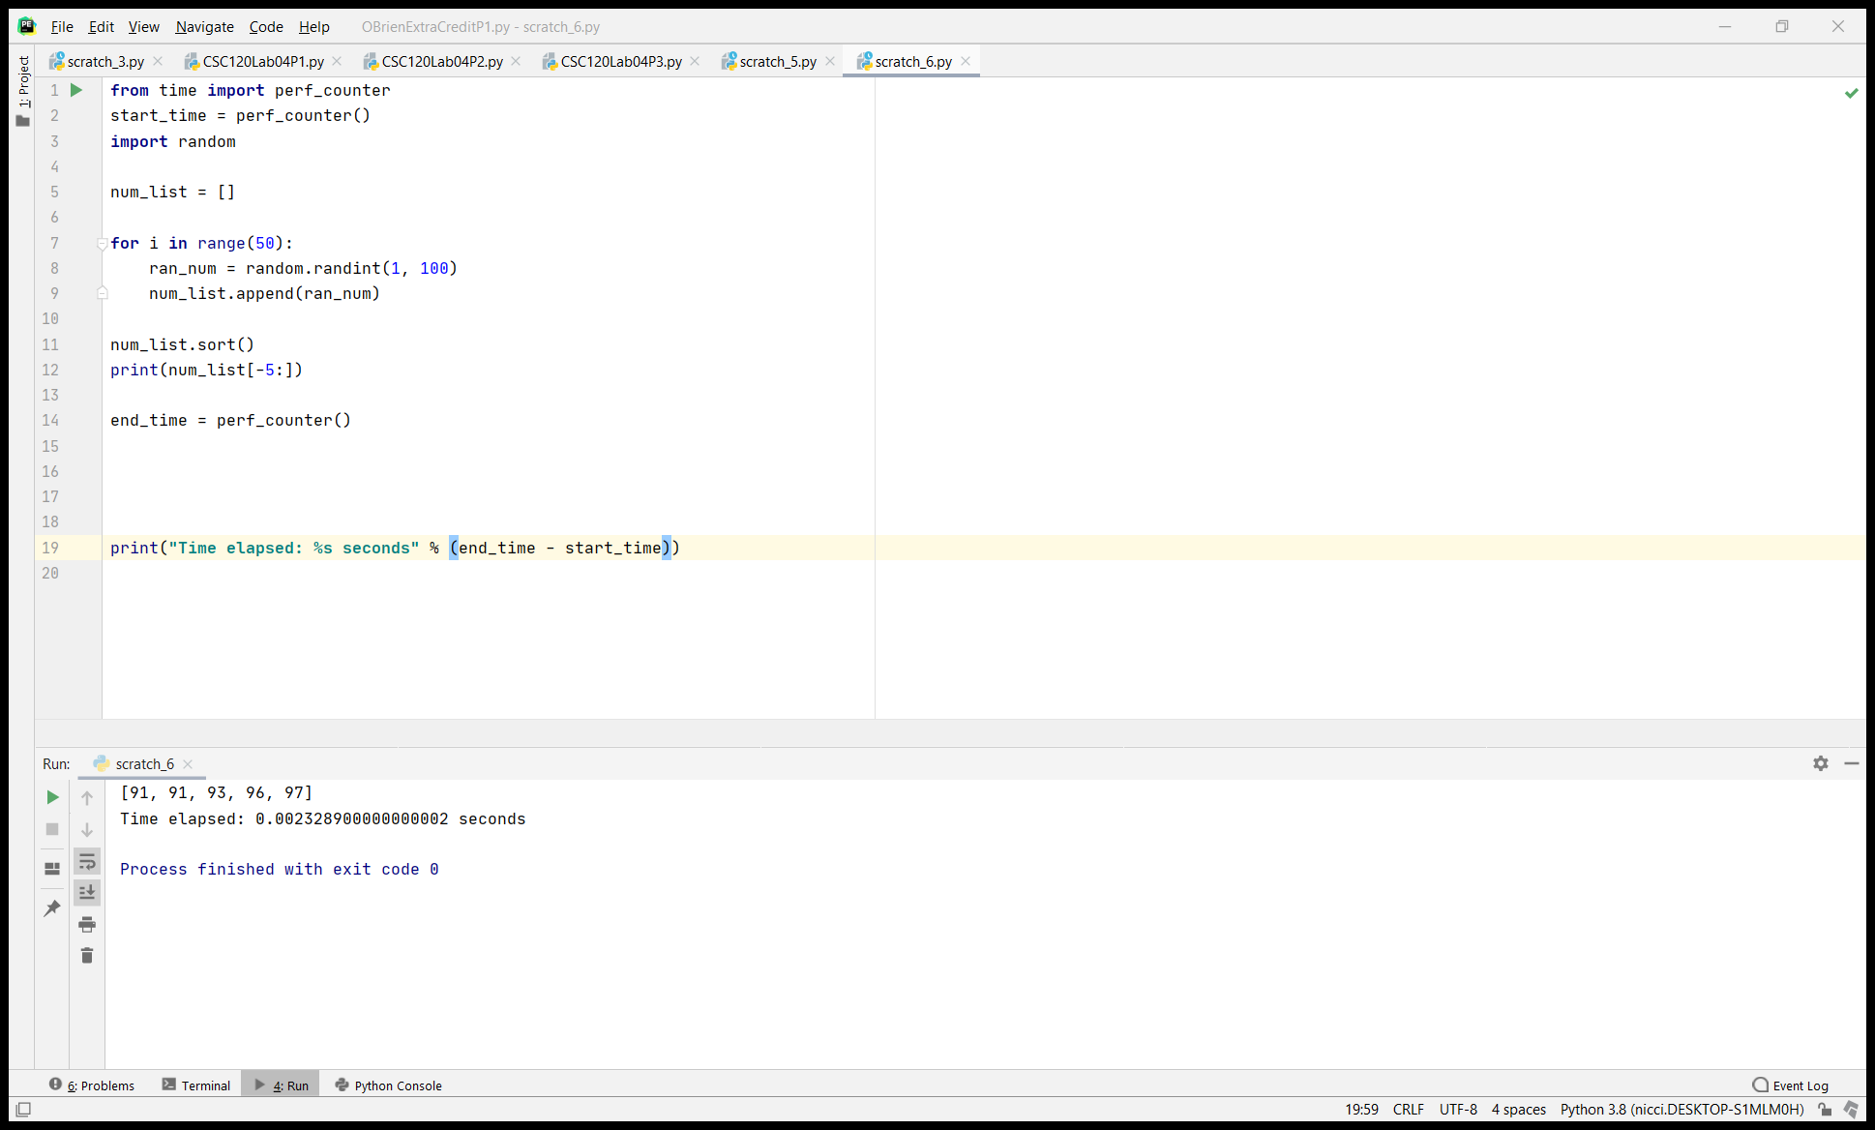

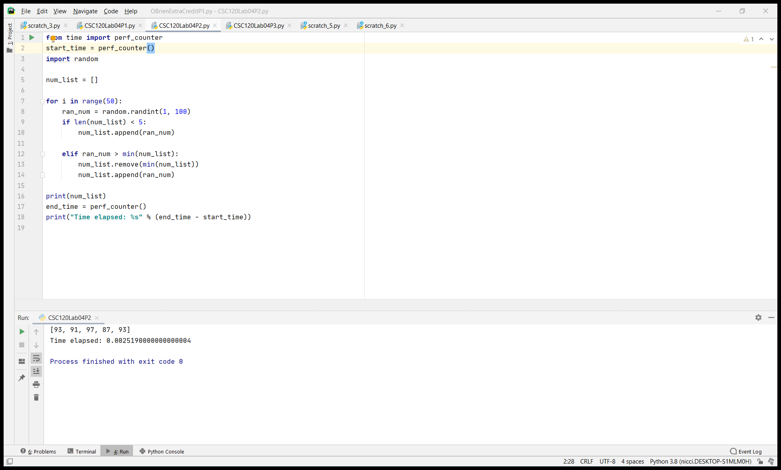

**Instructions: Upload the file with the screenshot on Blackboard with youyr firstname_lastname.docx**

(Not an extra question, but just did this for fun and worked with the time module perf_counter to test between built-in string.split and imported re.split) string.split() method:

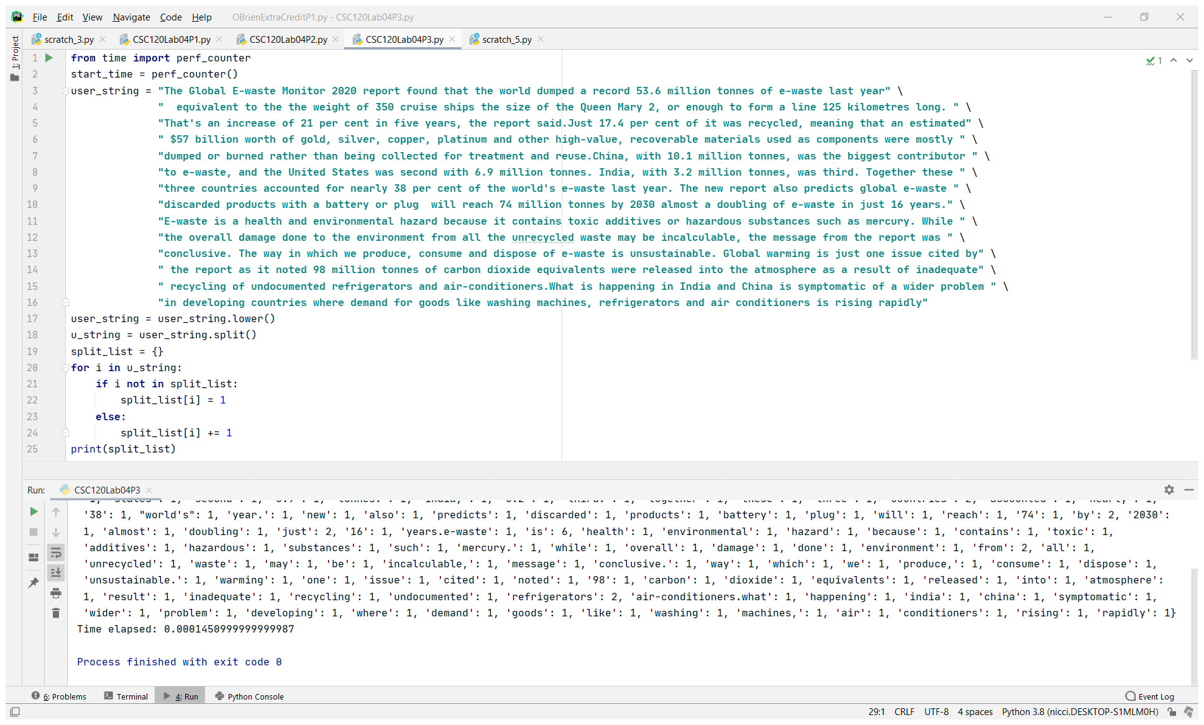

With re.split:

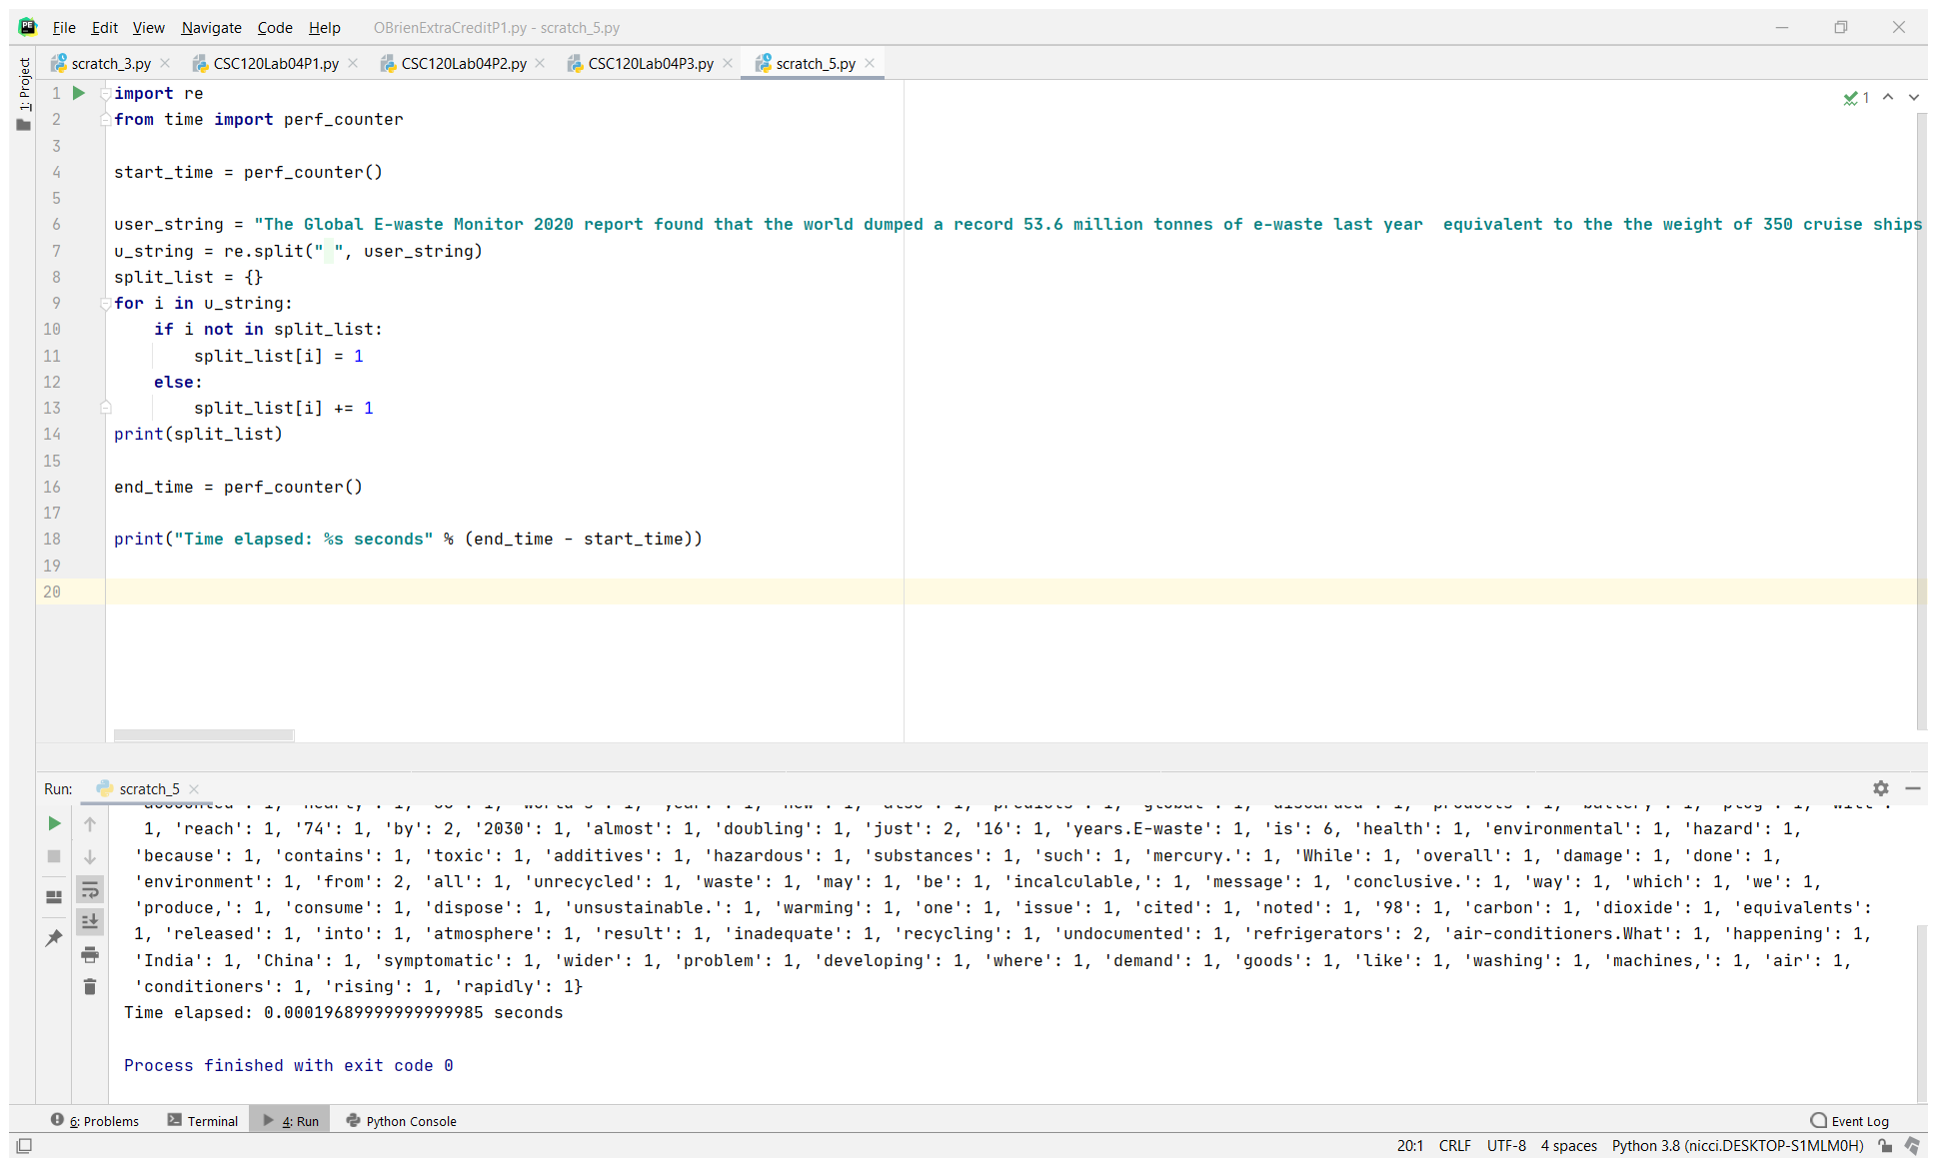

(Running short on time for all extra credit questions, but I will happily look them up at a later date!)